

**UNIVERSITI TEKNOLOGI MARA (UiTM)**

**CAWANGAN MELAKA KAMPUS JASIN**

**USER MANUAL: COUNSELLOR BOOKING SYSTEM**

**Group Members:**

|  |  |
| --- | --- |
| **Name** | **Matric No.** |
| Itmam bin Md Khairi | 2017720431 |
| Affiq Mirza bin Abdillah | 2017958663 |
| Nur Hazirah binti Abdullah | 2017789301 |
| Faiznur Asikkin binti Abdul Latif | 2017181631 |

**Made By : B-Couns**

**Table of Contents**

|  |  |
| --- | --- |
| Contents | Page |
| Table of Contents | 2 |
| Introduction | 3 |
| Snapshots of the System: Common Page | 4-5 |
| Snapshots of the System: Admin | 6-8 |
| Snapshots of the System: Counsellors | 9 |
| Snapshots of the System: Users | 10-11 |

**Introduction**

Counsellor Booking System by B-Couns is a booking system designed especially for three users; Customers (Users), Counsellors, and Admin.

This system provides an easy way for the counsellors to know each session they have, and for the customers to easily book an appointment with the counsellor they wanted without any hassle.

This user manual provides a step-by-step operation needed to be done by the users of the system.

**Common Page :**

1. Main Page

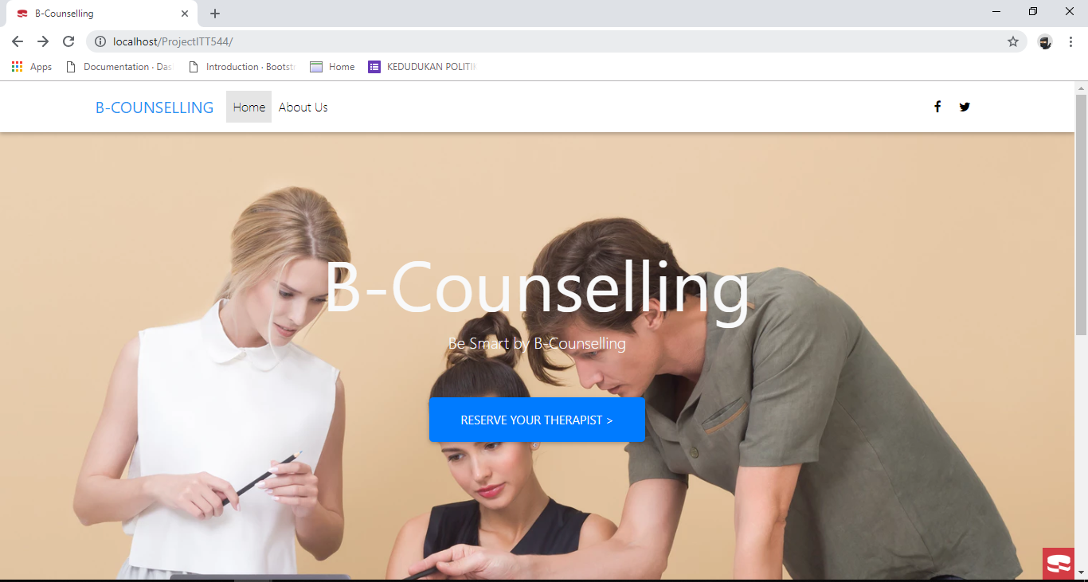

All of the users of the system will first be redirected to the main page of the system.

1. Login Page

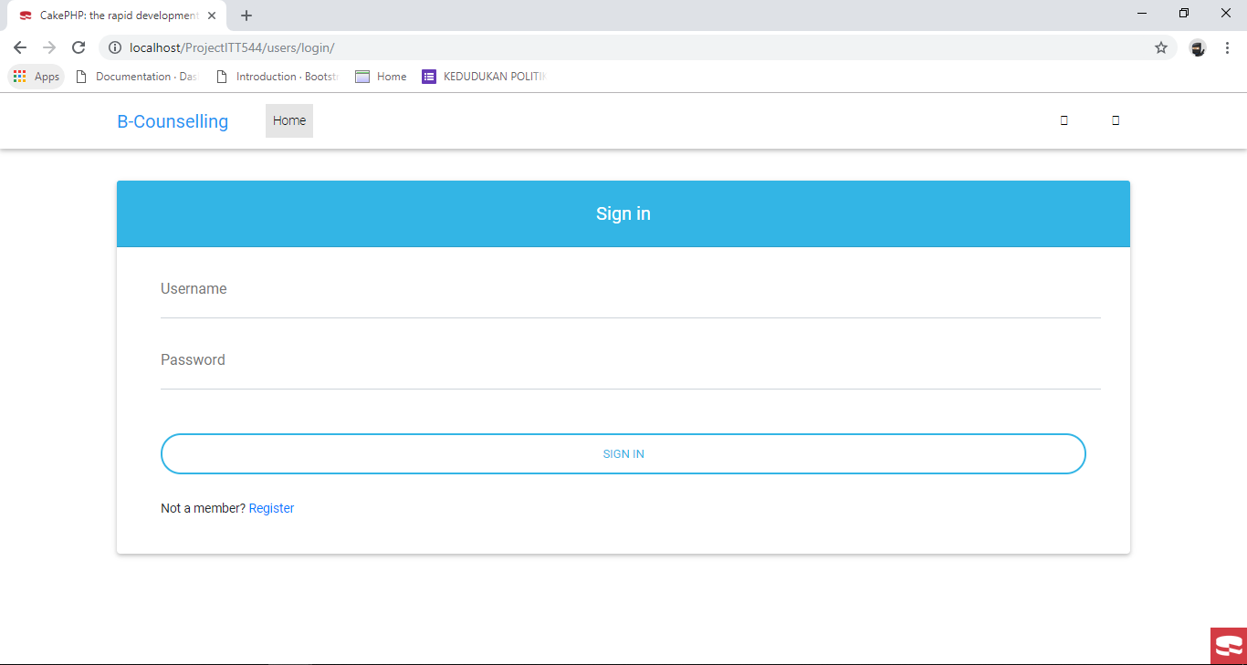

Login page for all of the users. Credentials will be checked using the roles they had assigned during registration.

1. Registration Form

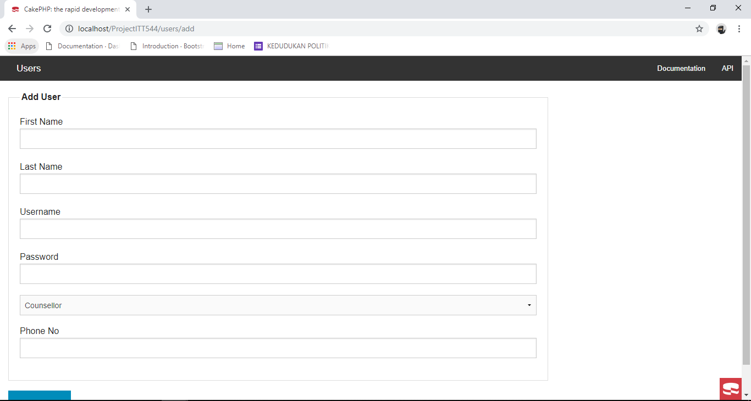

For the users whom have not signed up yet, the system provides a registration form. The credentials during the login will be set on it, using what they picked; Admin, Counsellor, or User.

**Admin**

1. Admin Interface

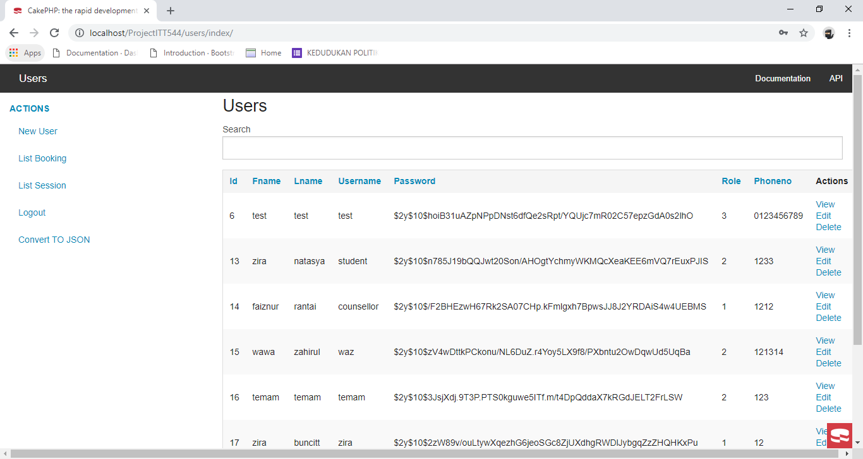

For the admin interface, provided all of the information regarding the booking sessions and the customer. Admin could easily View, Edit, Delete, and Search the list of users.

1. Booking List

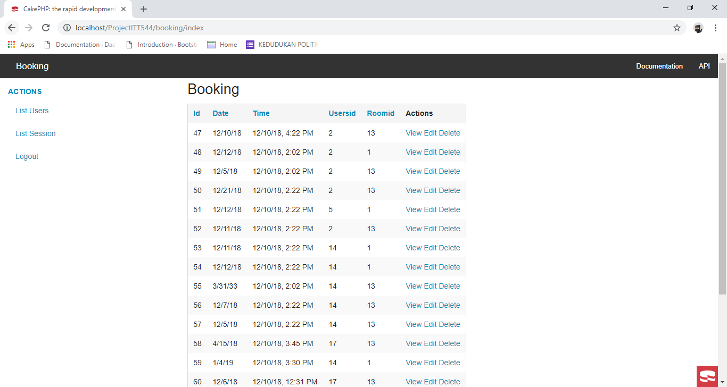

Booking List is provided to see the users ID, and the rooms ID for each booking session.

1. Session List

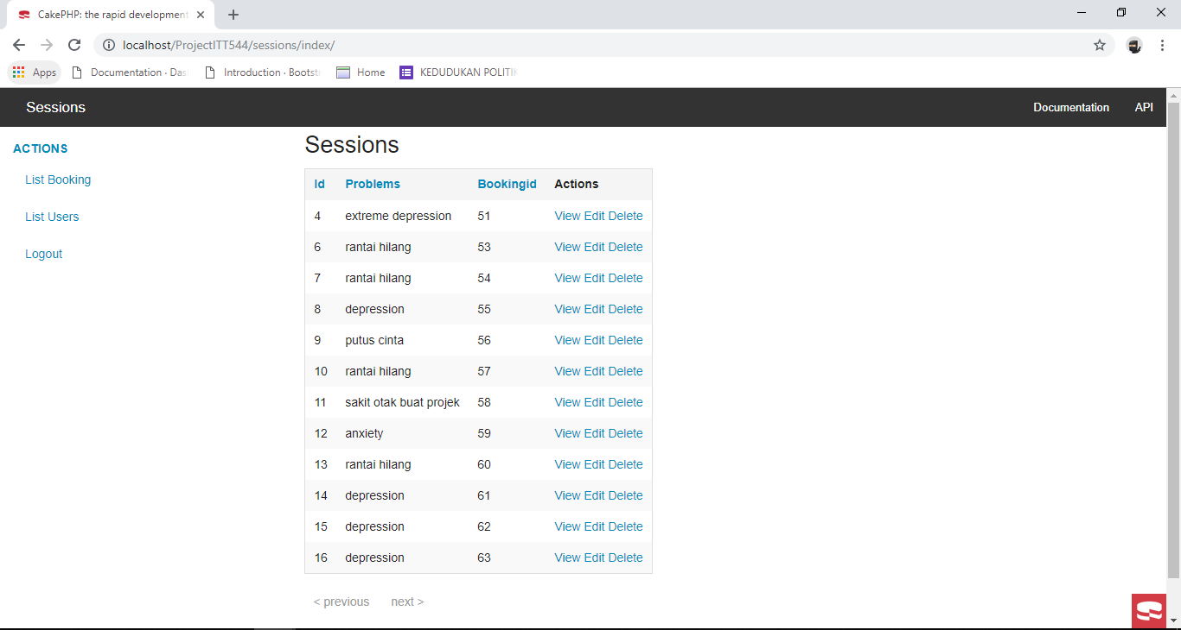

On Session List, provided the lists of problems that the clients had, and their booking ID.

1. Search List of Users

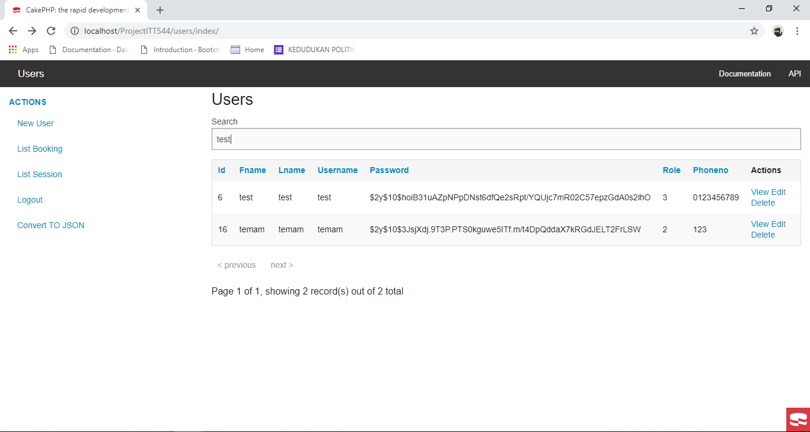

The system uses AJAX and an auto-search for searching.

1. Convert to JSON

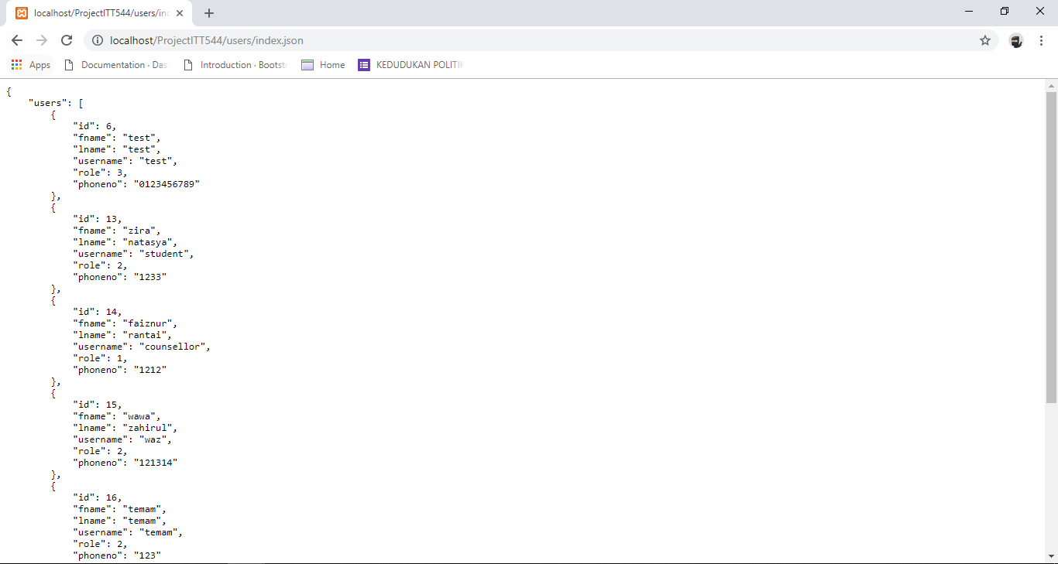

The system is able to convert the user data, into JSON file.

**Counsellor**

1. Counsellor Interface

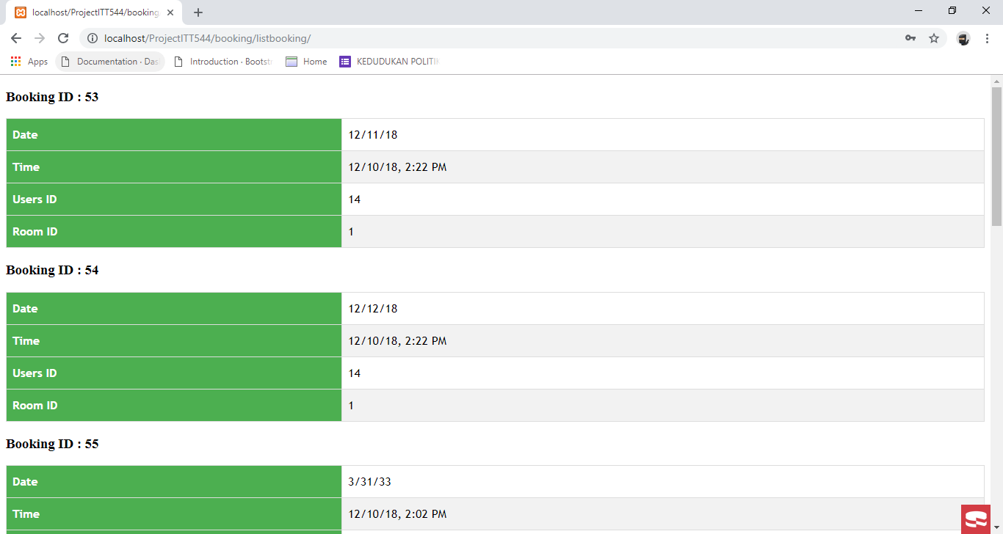

Counsellors’ Interface is for a display of what time of sessions they have, and to keep track of each sessions with their customers.

**User**

1. Choose Counsellor

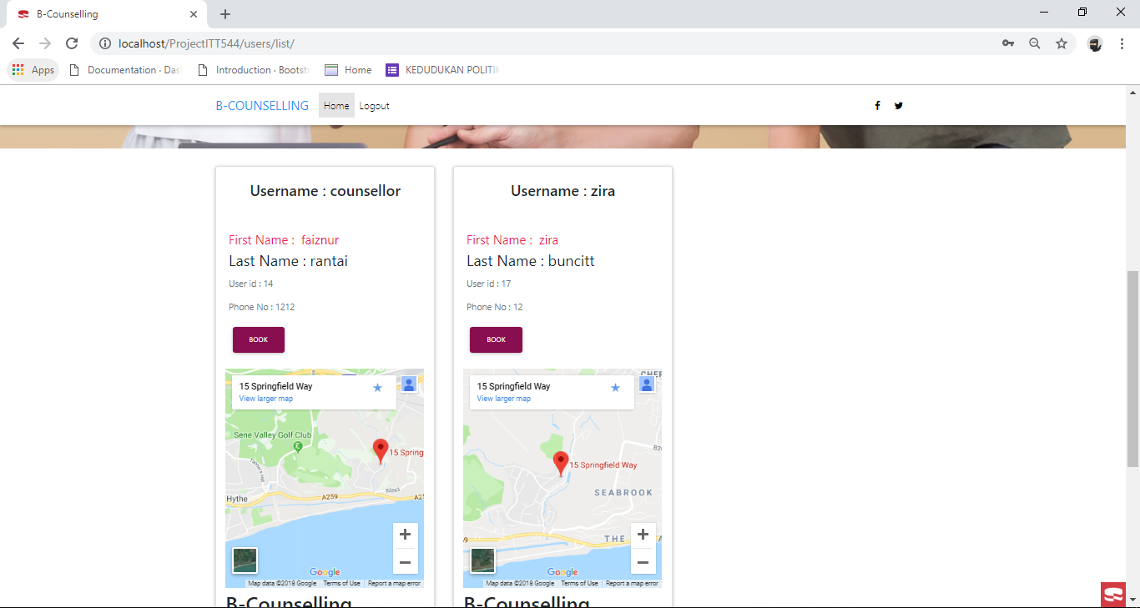

For users, after they had successfully logged in into the system, they will be redirected to the homepage whereas they had to choose the counsellor they wanted to be counselled with.

1. Add Booking

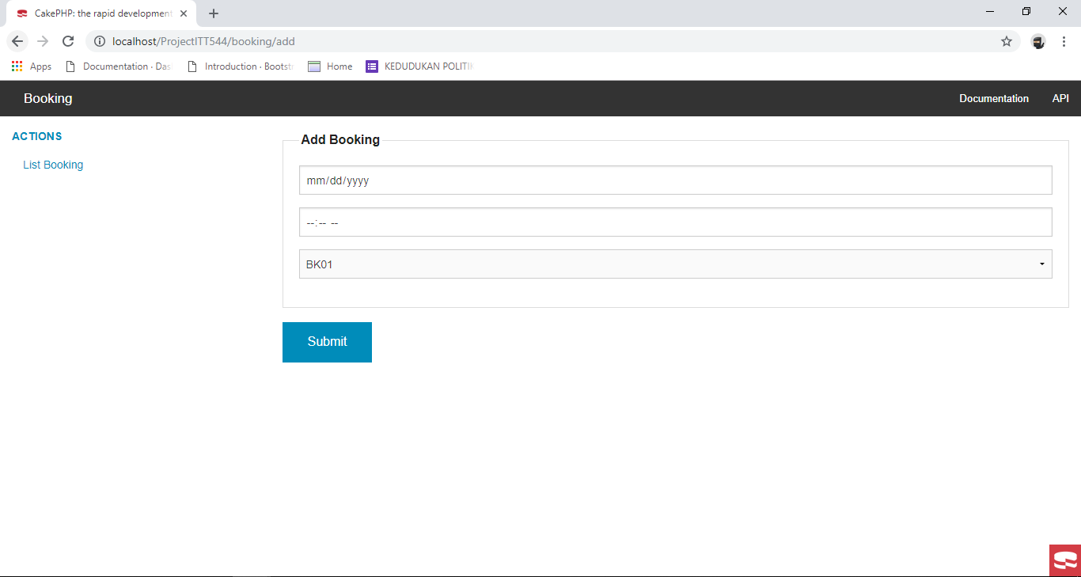

This page is to add booking time for the counsellor, as for what time, and where should the appointment be.

1. Add Session

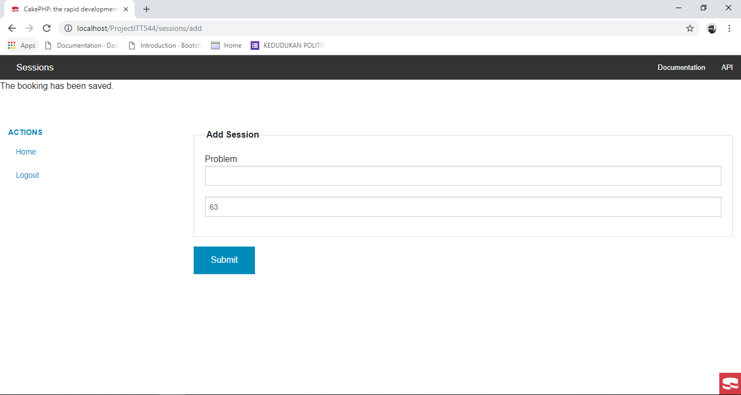

This page is to add session for the booking; for the users to express the main appointment of what it is about.

After the users had logged out, they will automatically be redirected to the main page.